**Lesson 07 Demo 1**

**Setting up Ansible**

**Steps to be followed:**

1. Install Ansible

**Step 1: Install Ansible**

1.1Use the below command to check and find the dependencies of the packages you want, and install any that are needed

***sudo apt-get install -f***

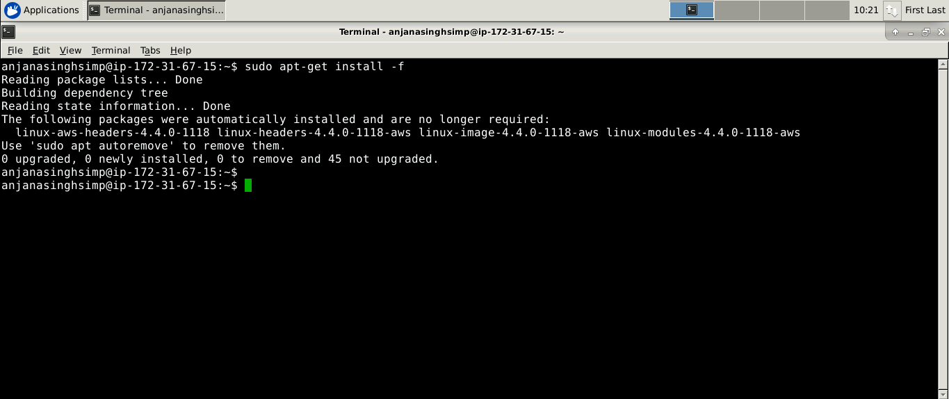

1.2Use the below command to update package repositories and get latest package information

***sudo apt-get install software-properties-common***

1.3Run these commands to update the list of available software once again and install Ansible. It also pulls down **Ansible PPA's** signing key and **adds** it to your system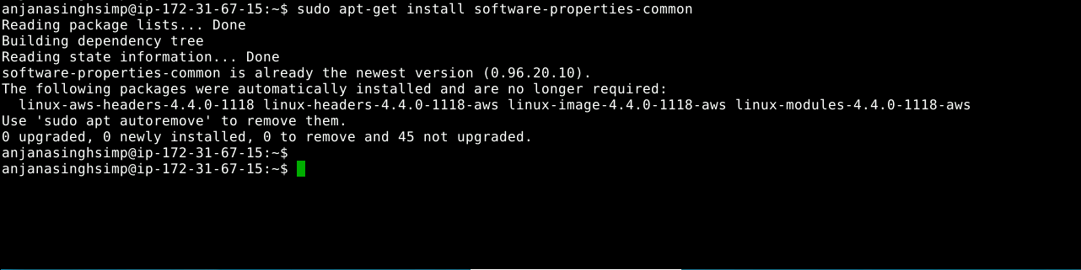

***sudo apt-add-repository ppa:ansible/ansible***

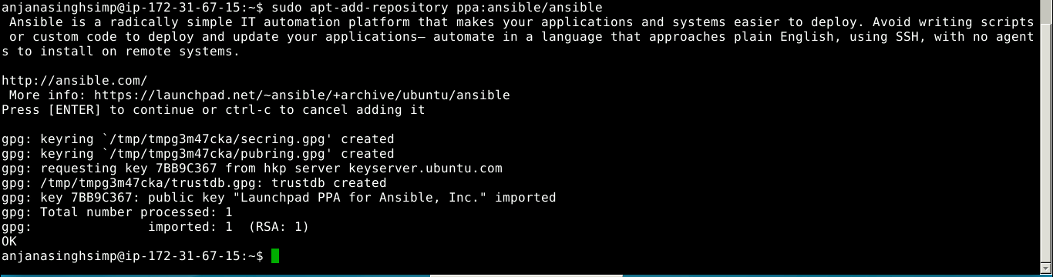

1.4Use the below command to download package information from all configured sources

***sudo apt-get update***

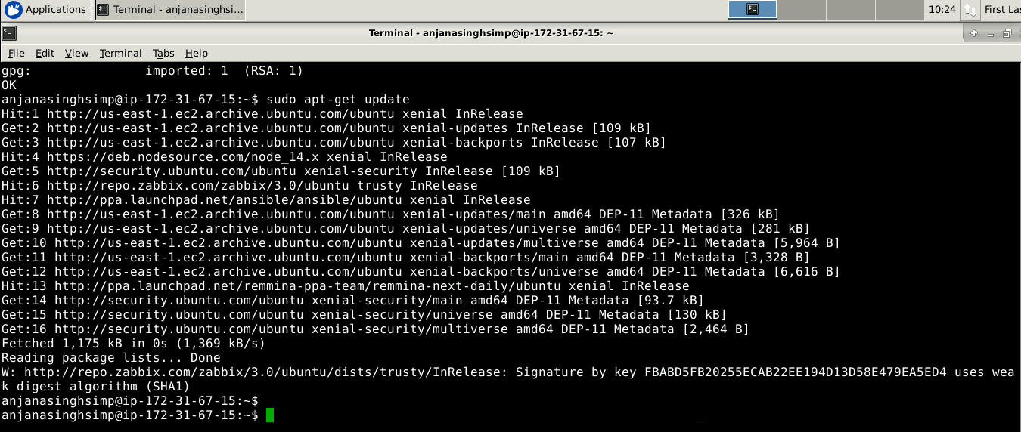

1.5 Use the below command to install Ansible

***sudo apt-get install ansible***

